Ethan Allen Round D Bed

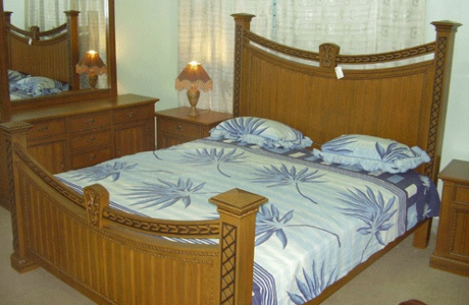

|  |
| --- |
| **DESCRIPTION** |
| Ethan Allen introduces a bed designed with round shaped bed head and foot. This bed is guaranteed to create the perfect look in any house. The rich wood and round shape lifts the pressure from the bed of having perfect look. The wood used is very special as it is rarely found. The comfortable level of this bed is very high with flat spring mattress so that it does not lose its elasticity and stay together in place. |

|  |  |  |
| --- | --- | --- |
| **Price** | **1500$** | |
| **Dimensions** | **H** x **W** x **L** | **34in x 50in x 73in** |
| **Features** | **Springs used in mattress helps the mattress to adjust according to the weight of the body so that it does not lose its elasticity.** | |
| **Finished** | **Hard Polished Brown Wood** | |
| **Available in** | **Black and Brown** | |